Duffield Rackets and Fitness:
Reshaping our Club for the 21st Century

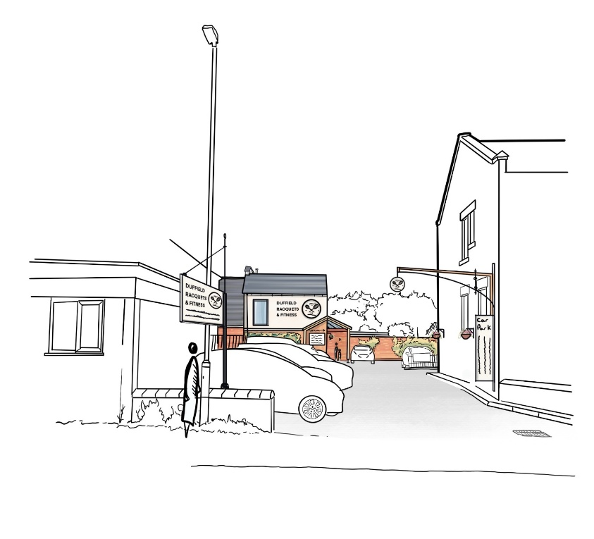

Context
The 2023 flood and subsequent merger of squash and tennis presented us with the opportunity to consider the club’s future. Consultation with the membership identified two main issues for the continued success of the club.
- The need to modernise our ageing and tired-looking premises to the standard offered by other venues if we are to continue to attract members.
- The need to keep up with changes in the health and fitness market - squash membership having declined significantly in recent years while the fitness and gym market is growing.
In terms of modernisation, we consider the following improvements essential:
- improved gym and fitness facilities to allow us to capitalise on a growing market and younger demographic
- refurbishment of changing rooms to meet modern standards of comfort
- updating of bar and social facilities to encourage increased use
- create an access for disabled people and make the club more appealing.
Design Brief and Council Recommendation
A brief for the redevelopment of the club was drawn up, and several iterations of plans have been produced by our architects. In phase 1, we have options for a full internal redevelopment with three squash courts, and a partial redevelopment retaining four squash courts. Phase 2 would address improvements to the grounds, with proposals to cover tennis and pickle courts as well as installing padel facilities.
Although the original intention was to deliver the changing rooms as a standalone project, this has proven not to be economically viable. If the club had done this, once a wider redevelopment strategy had been established, much of the standalone work would have needed to be undone, effectively duplicating cost and effort.
The Council recommends that the full internal redevelopment best matches the opportunities and challenges we face. It offers a vision of a rackets club/leisure facility, with a larger, high-quality, commercially viable gym plus multi-functional studio spaces extending into the bar/lounge area to better accommodate social events. Partial redevelopment would not allow for a great enough transformation of the club premises to meet the changing market demands. In the opinion of the council, it would be a short-term measure leading to a gradual decline in membership.
Squash and Fitness Requirements
Extensive research on squash membership and court utilisation has shown that for most of the time, with the existing membership levels, demand can be met with three courts only. While significant efforts have been made recently to promote squash, club income from this sport continues to decline.
In contrast, the gym and fitness business at the club has increased, with two new personal trainers bringing new people into the gym, and a new fitness instructor running several classes a week on a squash court. Current facilities are sub-optimal (small gym and use of squash courts to hold fitness classes). The business case suggests that this section can generate revenue of up to £100k following redevelopment, assuming that a club manager with responsibility for fitness is employed.

Finance
Once members have approved the proposals, work still needs to be done on how the project will be funded. The club’s financial position is strong enough to merit a mortgage to meet the costs, but other options such as grants, sponsorship and fundraising will also be explored. The club is progressing its work on incorporated status, which will facilitate the financing and reduce members’ liability. This step will also be subject to members’ approval.
The future
The council is conscious that the process has taken longer than anticipated, partly due to the workload involved for us as volunteers, and partly due to the efforts made to bring the membership with us.
This is nevertheless a key moment in the club’s history, but just as our founders capitalised on new sporting trends to set up the tennis and squash clubs in the nineteenth and twentieth centuries, we hope to do the same in the twenty-first. We can only succeed, however, with members’ continued support, so we urge you to vote to accept the Council’s recommendation for the full redevelopment option.

